Course Name | ITD 2343 – Object Oriented Programming with C#
Instructor | Mark L. Pranger
Student Name | Eric Christensen
Due date | 11/23/2025
Grade | <grade earned here>
Grading Comments | <instructor comments here>

Section 3 – Lab Exam

Submission Requirements
- The form in a screen shot as built in the IDE
  - A minimum of 3 different screen shots showing the progression.
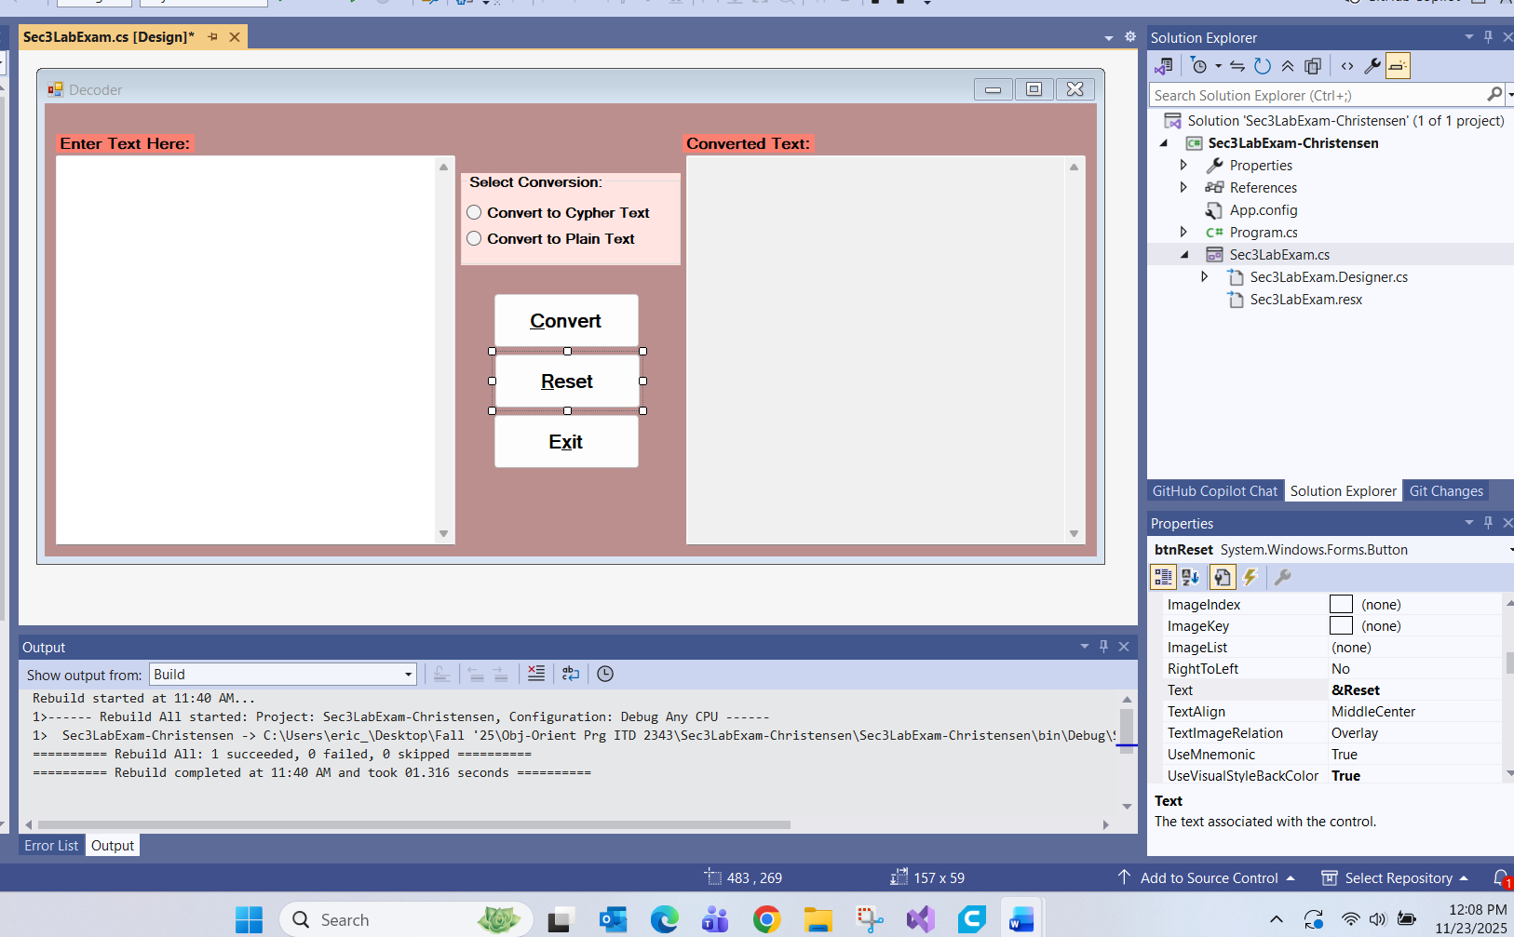
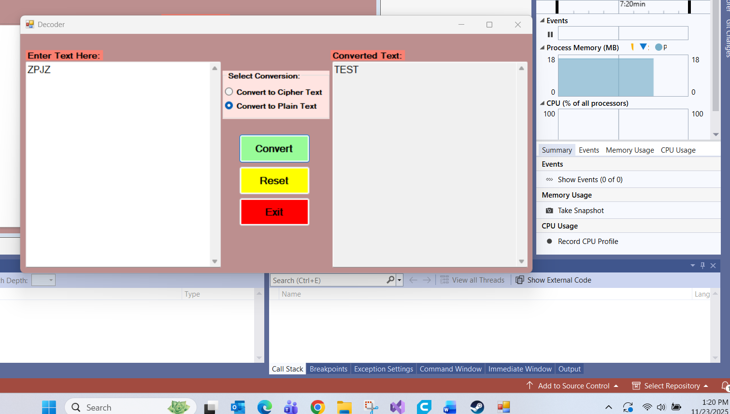
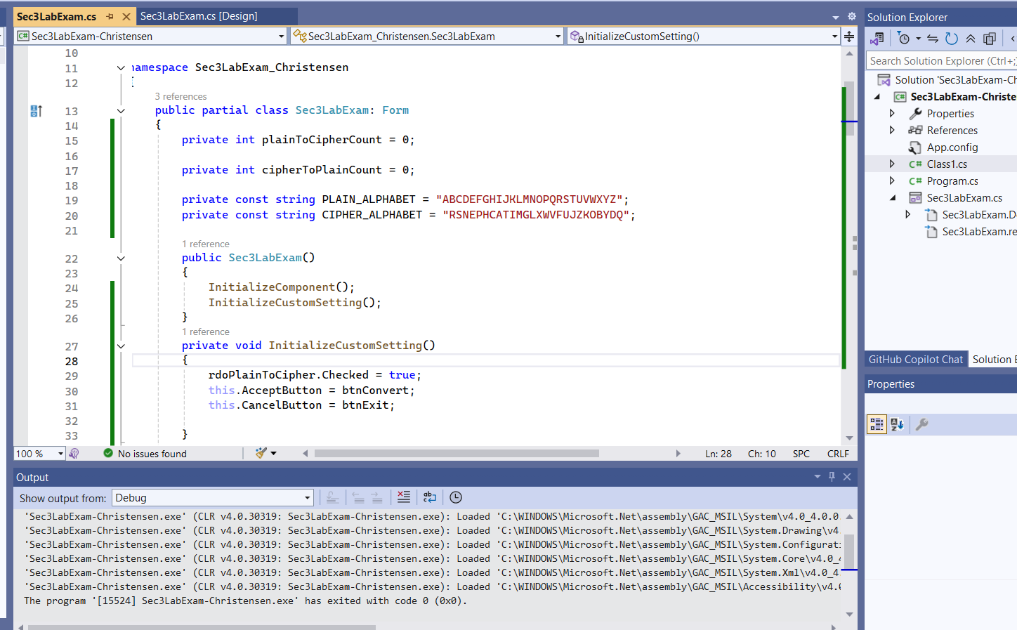

- Screen shots of the form as seen when the program is executed.
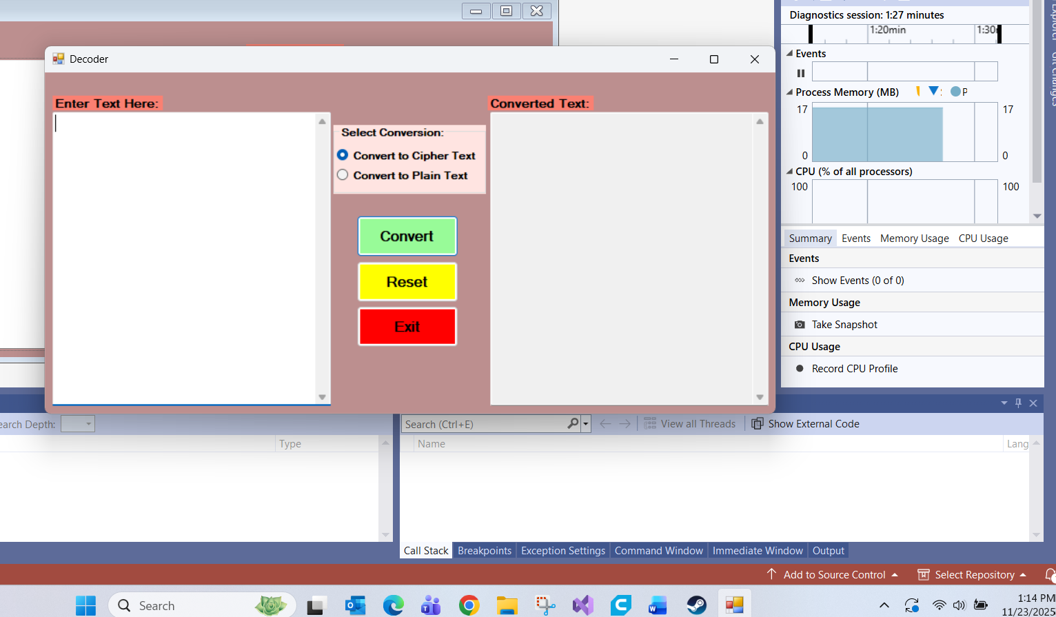
  - One Screen shot showing results with the following set of data being entered by the user:
    - Enter your name and covert it to Cipher Text
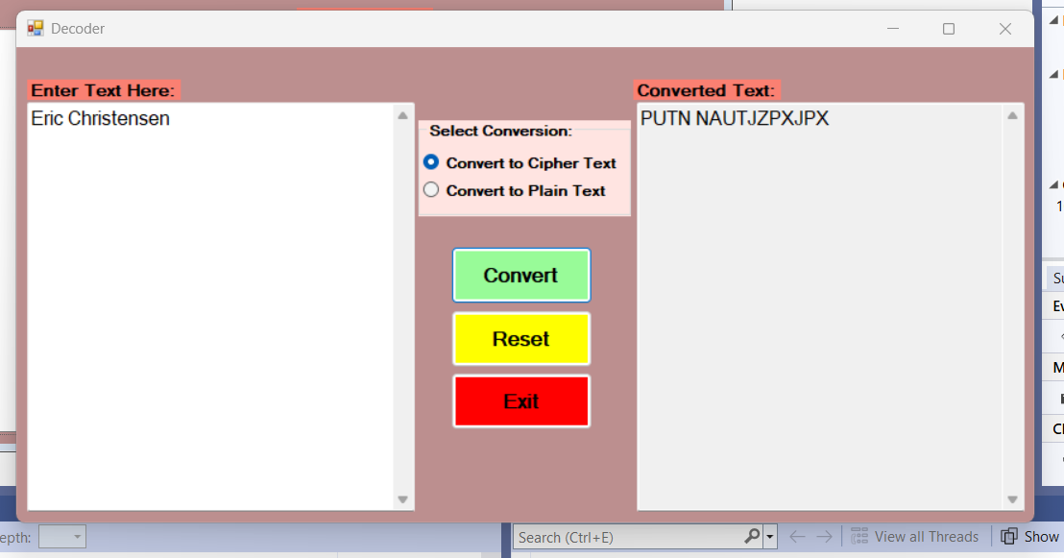
  - One Screen shot showing results with the following set of data being entered by the user:
    - Enter Professor Greg Morris and convert it to Cipher Text
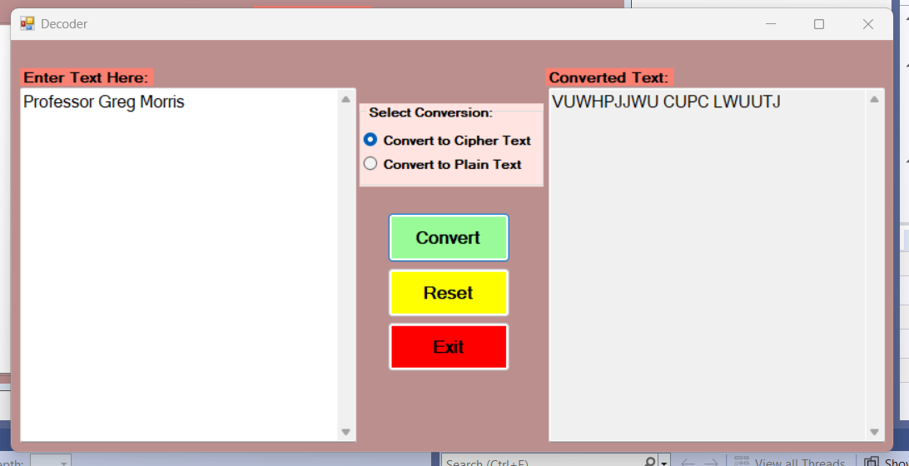
  - One Screen shot showing results with the following set of data being entered by the user:
    - Convert the following phrase to Cipher text: Four Score and Seven Year ago.
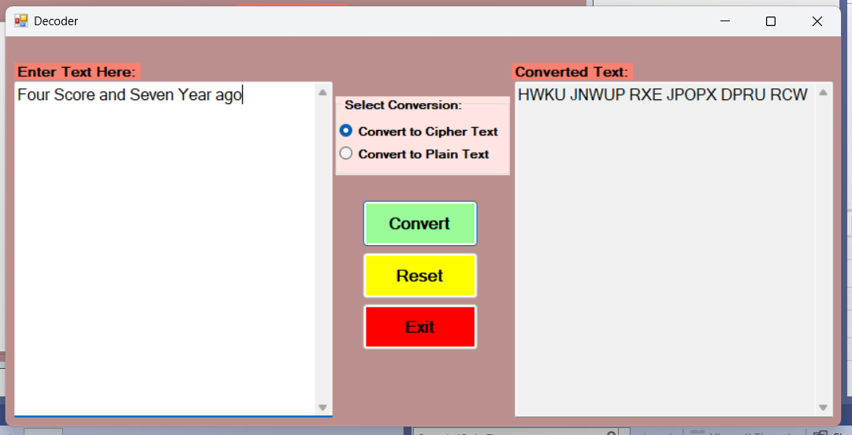
  - One Screen shot showing results with the following set of data being entered by the user:
    - For giggles, use your name as cipher text and covert it back to plain text to see what it says
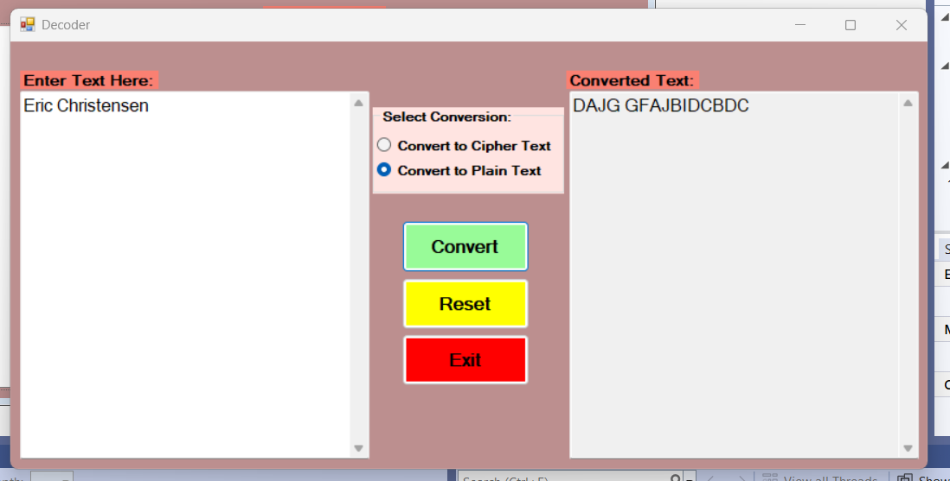
  - One Screen shot showing results with the following set of data being entered by the user:
    - Show the plaintext of the following cipher text phrase: "HfVFo EIcN OFv oI MkX np"
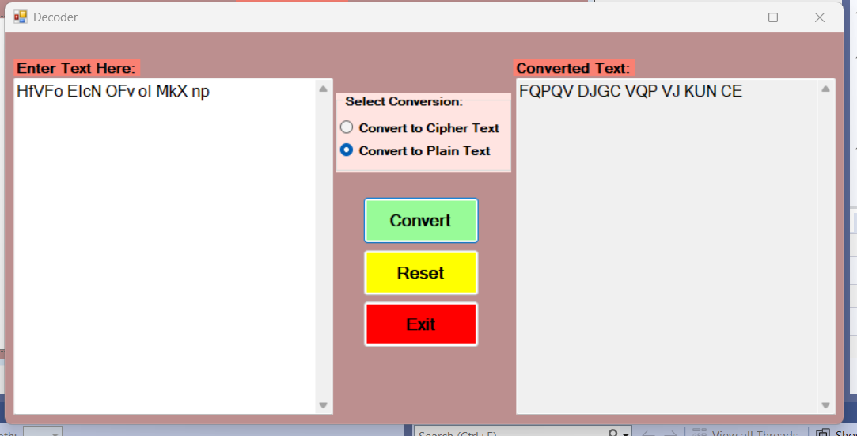
  - One Screen shot showing results with the following set of data being entered by the user: (error case)
    - Show the error when you try and convert an empty input to cipher text
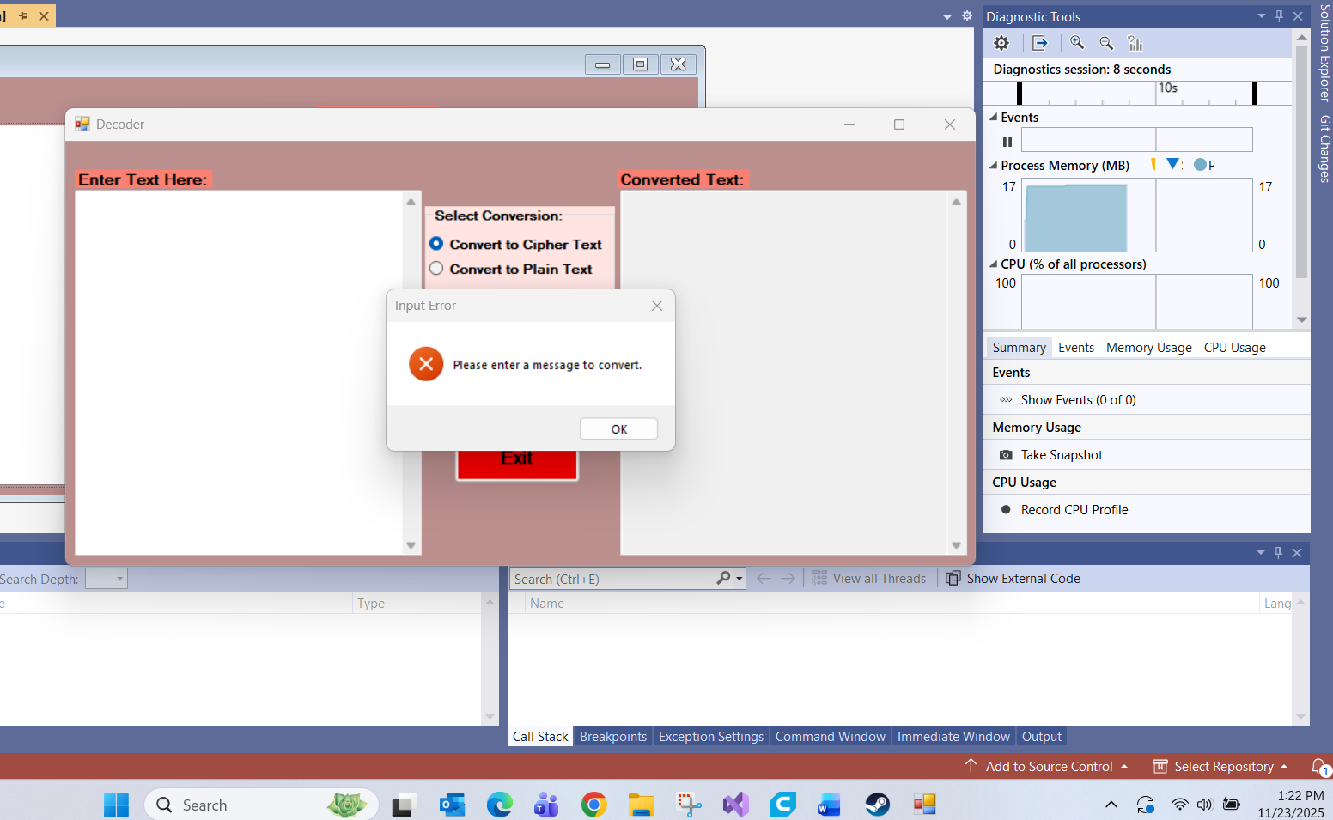
  - One Screen Shot showing the Message Box when you exit the application that says how many Messages were converted
    - Be sure to show that you have converted both types of messages (Plain to Cipher and Cipher to Plain)
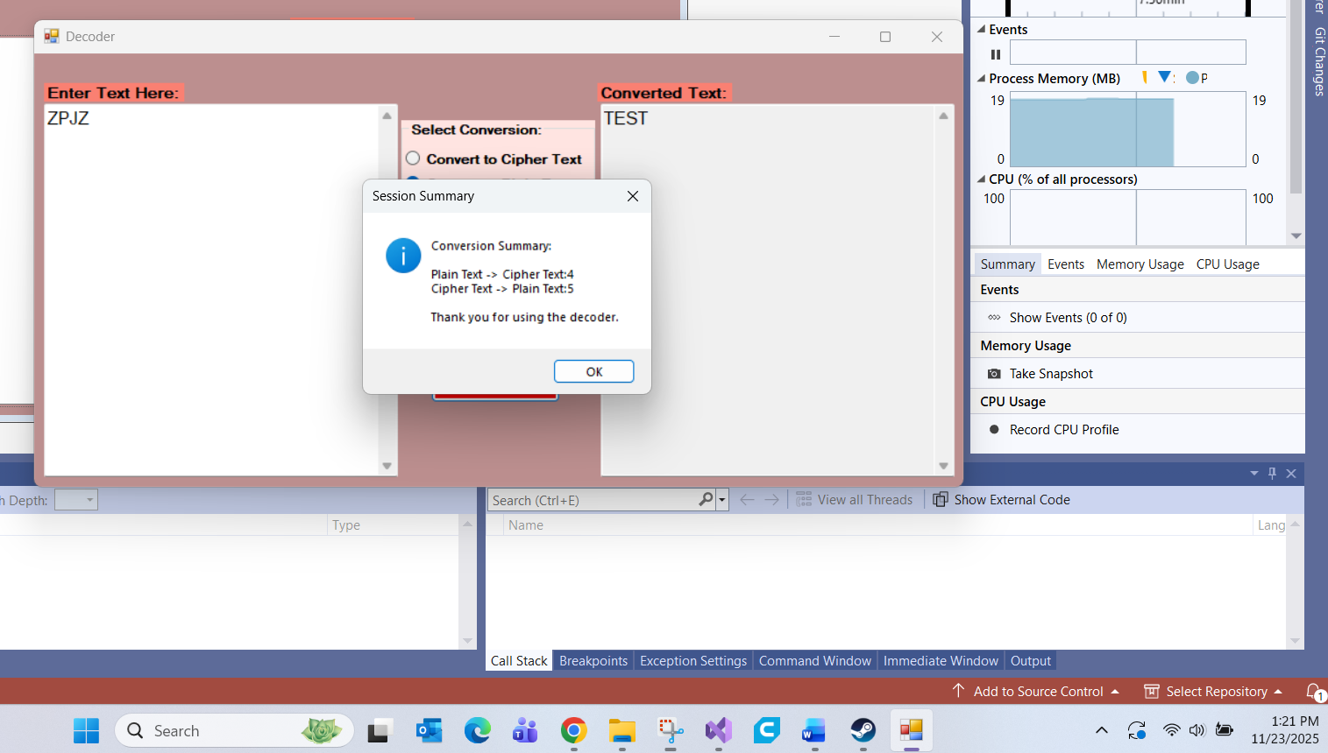
  - the form as it starts (Program Initiation)
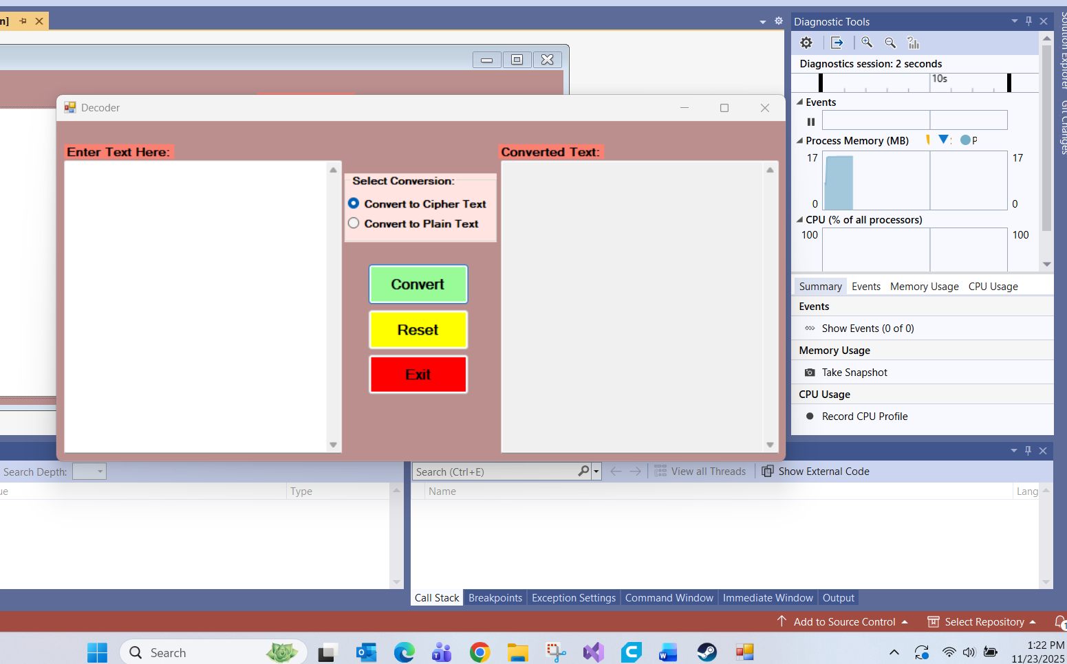
  - the form after the Reset button is used (Functional Operation)
